Galerie La Ferronnerie
Brigitte Négrier
40, rue de la Folie-Méricourt
F-75011 Paris +33 (0)1 78 01 13 13
www.galerielaferronnerie.fr
Membre du Comité Professionnel des Galeries d’Art

7 – 11.02.18 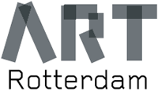 Stand 55 - Van Nelle Fabriek, Rotterdam NL

Frédéric Coché, Laurent Fiévet, Soo Kyong Lee, Jérôme Touron

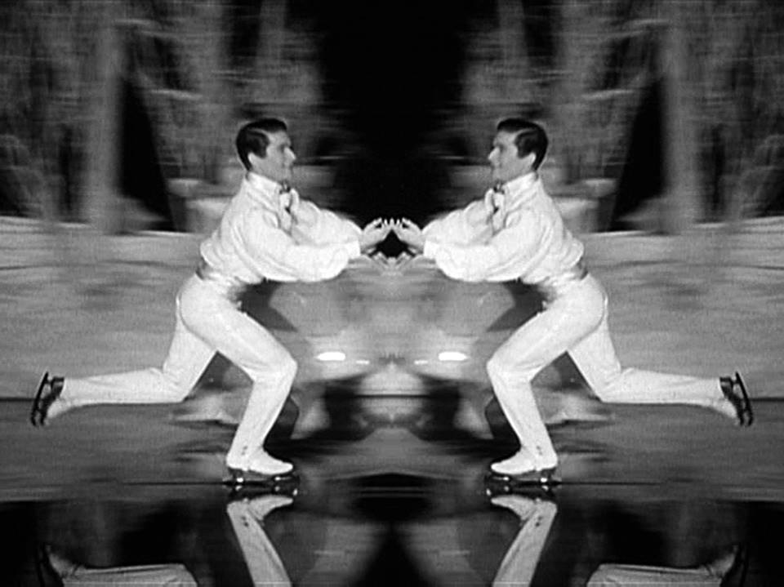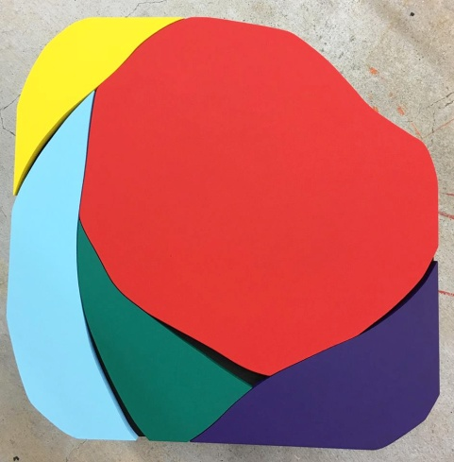

Laurent Fiévet, Coming out, 2012, video Soo Kyong Lee, acrylic /wood, 2018

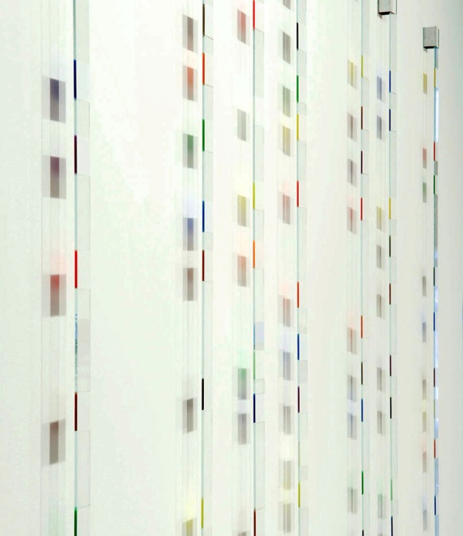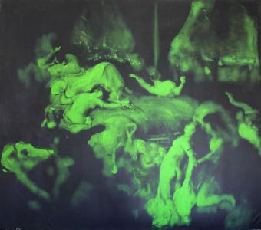

Jérôme Touron, Lames, 2006 Frédéric Coché, La mort de Sardanapale, 2012,130x150cm

Laurent Fiévet creates video editing from famous movies, such as the piece we will show at ART Rotterdam 2018, to which he sometimes add some elements, thus elaborating installations. The video Coming Out is structured around the last ballet sequence in H. Bruce Humberstone’s Sun Valley Serenade, which showcases the ice skating talents of the Norwegian actress and figure skater, Sonja Henie. After having shown the young woman skating alone on an artificial lake to the rhythm of a piece of orchestral music, the video cuts to a short duo with a male partner before ending on group scenes where couples of ice skaters in ball attire and men in military uniforms curiously appear together. The appearance of the soldiers takes on special sense when regarded from this perspective, pointing to the threat of the ongoing repression of homosexuality in many countries around the world.

Galerie La Ferronnerie
Brigitte Négrier

Soo Kyong Lee was born in Seoul in 1969 and has been working in Paris for 20 years.
François Michaud, Chief Curator at MAM (Musée d’Art Moderne de la Ville de Paris)
about Soo Kyoung Lee artwork* :

« …We should, if we wanted to be exhaustive, mention the names of Pollock, Rothko, Motherwell, and Ellsworth Kelly… and moreover of Barnett Newman to relate to Soo Kyoung Lee’s work. It’s Barnett Newman, more than any other, whose formal interventions still express themselves in Soo Kyoung Lee’s work. The vertical cuts in the canvas, sometimes, or the polyptych constructions more and more frequent in her work, are obviously linked to Newman’s universe – but it is not simple, despite an apparently obvious comparison. One needs to patronize both painters’ works, especially when one is as famous, in order to precisely abstract all tentative imitation. Diverting after becoming closer. It’s at this moment when you are close to the master, when you are able to see him like an illusion, when you can almost speak that he slips away, like some ghost; he leaves you at your duty, with the consciousness of having nothing to say anymore…»
*in catalogue solo show at Gallery604, Seoul, South Corea, 2016

Frédéric Coché (Pont à Mousson, France, 1972) uses paintings, drawings etchings to build artworks that very often deals with Human destiny. For this edition of Art Rotterdam, the gallery will exhibit La mort de Sardanapale (130x150cm)*. Worried that his palace was about to be taken by his father, Sardanapale prepare his sucide. He put to death his wives, servants and horses and ordered to burn evereything. Frédéric Coché says about this work ‘ I’am seeking, let myself guided to my memories.
An art piece can be reframed, reappropriated and have a new meaning without changing his first significance ‘.His artworks are in many private and institutionnal collections, such as
Musée of Art and History,Geneva (Ch) Musée des Beaux-Arts de Nancy, France etc..
*The original painting is from Delacroix and its exhibited at the Louvre in Paris.

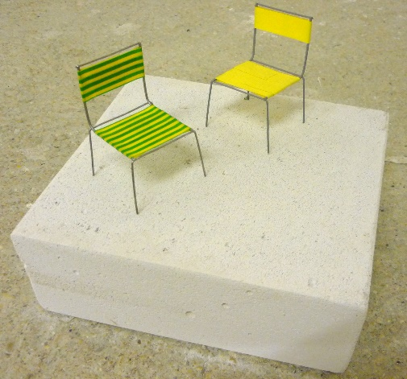

Jérôme Touron, Conversation, 2016

Jérôme Touron works with galerie la Ferronnerie since 1992, and has been exhibited to the Zurich Fair, Amsterdam, Rotterdam, Knokke, Uccle in Belgium, Erlenbach-Zurich. More recently,
Jérôme Touron showed a group of works at the APCD Fondation, Marly-Fribourg (Ch).
One of his artwork, series Règlement can be seen at the Voorlinden Museum, The Hague, in the current show ‘Stage of being’
For Art Rotterdam 2018, we will present a series of Lames, and a group of pieces showing Jérôme Touron’s evolution in his working process, as a tribute to his 25th years of collaboration with
galerie La Ferronnerie.
The artist’s works could be considered as post-minimalist but the spirit he put in it gives a poetic touch, sometimes he likes to add a touch of humour. His works are in important private collections, he also got a grant from the Krasner-Pollock Fondation, USA.

For more infos and images please contact Brigitte Négrier
bn.ferronnerie@gmail.com

www.galerielaferronnerie.com

